Acknowledgements
Add acknowledgements here. If you do not wish to add any to your thesis, comment out this section.

Abstract
The abstract should be 1 paragraph long, summarize the important results and state the significant conclusions. It needs to be self-contained and not refer to any other written section, graphs, and tables contained within the thesis. Math, special symbols and/or citations should generally not be used in an abstract. Key results must be presented. Values of important experimental or simulation parameter ranges must be included. A quantitative statement about agreement or disagreement between theory and experimental or numerical results should be made.

Table of Contents
Acknowledgements iii
Abstract iv
Table of Contents v
List of Figures vi
List of Tables vii
Nomenclature 1
Chapter 1 Introduction 3
1.1 Manuscript Preparation 3
1.2 Figures & Tables 3
1.3 This is a subsection 4
1.4 Aims 4
1.5 Outline 4
Chapter 2 Methods 7
1.6 2.1 Another Bibliography Method 7
1.7 References 7
Chapter 3 Results 8
3.1 Equations 8
1.8 Multi-line Equations 8
Chapter 4 Discussion 9
Chapter 5 Conclusions 10
Bibliography 11
Appendix 1 Detailed Mathematical Derivations 12
Appendix 2 Extra Details of Experimental Instrumentation 13
Index 14
Pocket Material: Map of Case Study Solar Systems 15

List of Figures
Number Page

Figure 1. This is a figure. 4

List of Tables
Number Page

Table 1. This is a table. 4

Nomenclature
- A super important variable.
GPS. Global Positioning System.

Introduction
The introduction should generally contain:

  - A clear and concise problem statement.

  - A literature survey explaining the state-of-the-art and contextualizing the problem in terms of the "knowledge gap the thesis addresses".
  - The motivation for studying the problem.

  - The significance of the work presented.

Note that other formats can also be used for enumeration, such as the following:

- This is always the first letter in the English alphabet.

- This is always the second letter in the English alphabet.

- This is always the third letter in the English alphabet.

- I think you see what I mean now.

Manuscript Preparation
Tables, figures, equations and citations must be numbered consecutively in their order of appearance in the text.
Paper size should be A4 and the margins should be left=2.5cm,right=2.5cm,top=2.5cm,bottom=3.5cm
Language: The thesis must be written in English using a clear and concise style, free of colloquialisms. A useful reference is the Chicago Manual of Style, 15th Edition http://www.chicagomanualofstyle.org/about.html.
Citations: Here’s an example of a citation [1]. Here’s another citation [2]. These citations will appear in a big bibliography at the end of the thesis.
Symbols: You should define a nomenclature for symbols as they are introduced in the thesis.
Abbreviations and Acronyms: Abbreviations must be fully spelled out on first appearance in the abstract and in the text of the manuscript. Acronyms should be avoided whenever possible, otherwise they must be fully spelled out on first appearance.
Units: In general, SI Units (Systéme International) have to be used. Numbers should be provided in as short a format as possible, for example: 1.35 × 105 W stands for 135, 000 W. Decimal places that fall below the detection capacity of an instrument should be rounded, e.g. 1.4 mg, particularly in case of descriptions of axis in graphics. Volume data should be based on liters (l, ml, µl) or cubic meters (m3, mm3, cm3, dm3).

Figures & Tables
In Section 1.1 we discussed how to do citations; this sentence contains an example of how to cross reference a Section. All figures, tables and numbered equations appearing in the document shall be labeled and cross referenced.
Here, the command sequence "Shift + Ctrl + Space" is used to generate a non-breaking space. Each figure and table should also include a caption.

Note: The font used in figure annotations, plot axes and legends should generally match the font used in the main text. Matlab accommodates the use of latex fonts and math symbols within plots, making this fairly easy.

Figure 1. This is a figure.

Area | Count
North | 100
South | 200
East | 80
West | 140
Table 1. This is a table.

Aims
It is recommended that the introductory chapter include an Aims section where the main objectives and research questions/hypotheses are explicitly indicated.

Outline
It is recommended that the introductory chapter include an Outline section where a brief outline of the thesis is provided. In Chapter 2, the approach taken is presented in all of its gory detail. Chapter 3 continues in this vein and presents some rather disturbing graphics. The carnage continues in Chapter 4, where the implications of the main results are explored, ad naseum. The main conclusions of this sordid affair and some future recommendations for avoiding the mistakes gracefully implemented here are given in Chapter 5. Note, the listing of chapter content is only a guideline and other formats are permissible.

Methods
Describe how you approached the problem and any analytical, computational or experimental methods applied.

2.1 Another Bibliography Method
If you’d like to have separate bibliographies at the end of each chapter, do it like this:

References
[1] Mark Goresky and Robert MacPherson. “On the topology of complex algebraic maps”. In: Algebraic Geometry Proceedings, La Rábida, Lecture Notes in Mathematics. 961. 1981.
[2] William Fulton. “Introduction to intersection theory in algebraic geometry”. In: Regional Conference Series in Mathematics. 54. 1983.

Results
Describe your findings; tables and graphs are useful.

Equations
Numbered equations should be cross-referenced within the text. When cross- referencing equations, most engineering publications do not typically use the word "equation," but rather just enclose the equation number in parentheses, e.g., (3.1).
Note that grammar and punctuation should be continued through equations to form continuous sentences. One should avoid using a semicolon ":" before an equation, unless the equation is the first element in a list. A good reference that describes how to correctly write mathematical formulas in engineering and science papers is "A Guide to Writing Mathematics", by Prof. Kevin Yee:
http://web.cs.ucdavis.edu/~amenta/w10/writingman.pdf
Also note that upright fonts are generally used to denote the “d” in differential elements, e.g. $dx$.

Multi-line Equations

All equations shall fit within the width of the page. Breaking an equation is not always easy to do. Note that altering the math font size is not appropriate.

Discussion
Discuss your findings within the context of the literature survey provided in Chapter 1.

$$a=b$$ | (4.1)

$$a=b$$ | (4.2)

Eq. (4.1) is an example of equation. For each equation, the table should be copied. The left-side part (actual equation) uses the “Equation” style, while the right one (numbering) uses “Eq. Number” style. Reference to equations can be done by using the “Equation“ label (References->Cross reference->Label:”Equation” (Reference to: whole caption).

Conclusions
State the main findings and conclusions of your work here, reflect critically upon your approach. Make recommendations for future research and state any implications that your findings may have for the state-of-the-art or practice.

Bibliography

[1] W. Fulton and Conference Board of the Mathematical Sciences., Introduction to intersection theory in algebraic geometry. Published for Conference Board of the Mathematical Sciences by the American Mathematical Society, 1984.
[2] H. Y. H. Yushui and L. D. L. Dan, “Realization of sensorless vector control system based on MRAS with DSP,” 2008 27th Chinese Control Conference. Ieee, pp. 691–694, 2008.
[3] A. Parusiński and P. Pragacz, “Characteristic classes of hypersurfaces and characteristic cycles,” J. Algebr. Geom., vol. 10, no. 1, pp. 63–79, 2001.

In Scopus

Save your references from Scopus (www.scopus.com) in a .bib file 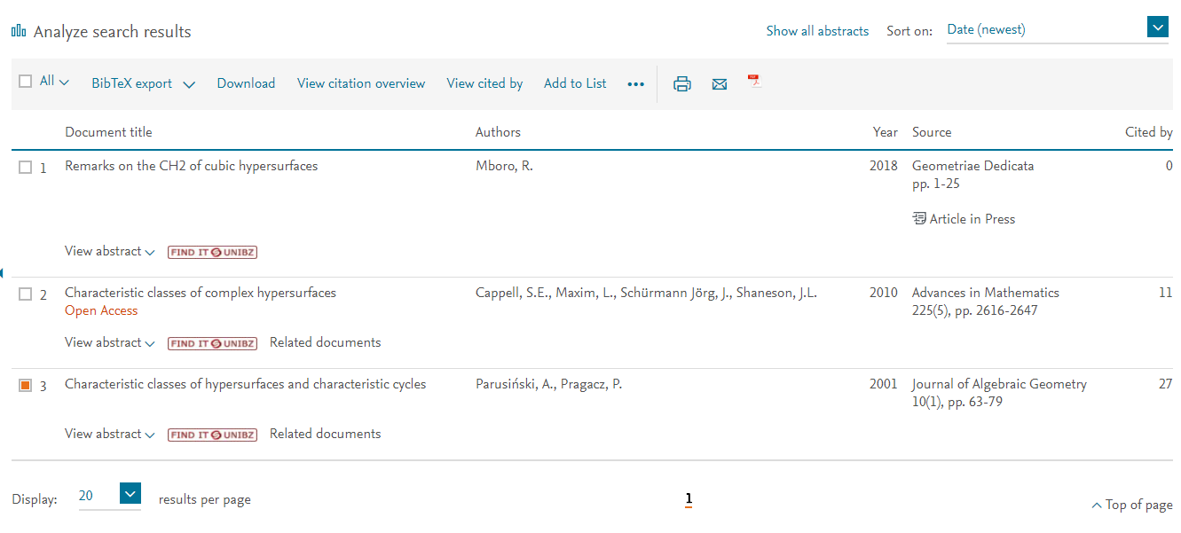
Download the software Mendeley (https://www.mendeley.com) and install it

Register a free account and login
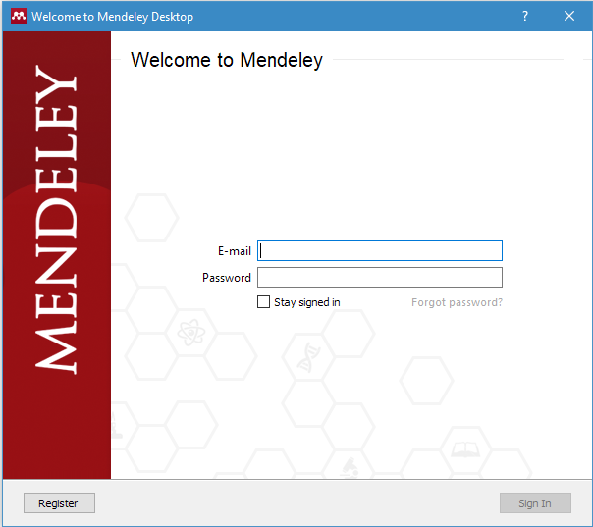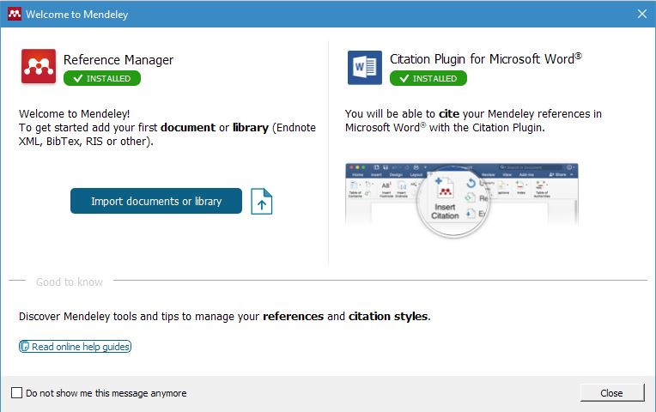
A new menu will appear in the “Reference” tab of your Microsoft Word.

In Mendeley (1.19)
To import new documents: (File->Add file ) and open your .bib document

It is recommended that the Mendeley Web Extension be used. This extension allows one to grab citations from web pages automatically (e.g. from ieeexplore.org or others), instead of having to insert the bibliographic data manually.

In Word (2016)
To cite a document in the text: (References->Insert Citation 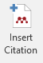) use “IEEE” style

Example: Parusiński et al [3] have studied….

To create the bibliography: (References-> bibliography )

- Detailed Mathematical Derivations

- Extra Details of Experimental Instrumentation

Index

B
bibliography, 2
by chapter, 5

C
chapter
numbered, 1
unnumbered, 1

F
figures, 3

L
LATEX, 1
T
tables, 3

Pocket Material: Map of Case Study Solar Systems

