[This page is intentionally blank]

Acknowledgements

Add acknowledgements here. If you do not wish to add any to your thesis, comment out this section. Take a look at the page numbering. This page is the first. Start numbering with letters, like i, ii, iii, etc.

Also, this first section is special for many

Abstract

The abstract should be one paragraph long, clear, concise (max 150 words). The style should be informative rather than descriptive. State purpose, experimental approach, significant results, main conclusions, and, finally, impact to food science field. Abstract needs to be self-contained. No references to other written sections are needed. Present key-results only.

Optionally, a graphical abstract can be also included. This is a visual, eye-catching drawing, which summarizes the main result of the work.

**Keywords:** keywords are important because they are used by search engines. Use from three to five keywords, separated by semicolon. Example: food; thesis; work hard.

Table of Contents

Acknowledgements i

Abstract iii

Table of Contents v

List of Figures vi

List of Tables vii

Abbreviations i

1 Manuscript Preparation 1

1.1 Figures 3

1.2 Tables 7

2 Outline (single paragraph in the introduction section) 8

3 Aims (single page) 8

4 Methods 8

5 Results and discussion 10

6 References 10

7 Equations 11

8 Conclusions 12

9 Use of Mendeley for Bibliography 12

10 Bibliography 13

Appendix 1 (optional) 15

Index (optional) 16

List of Figures

*Number Page*

Figure 1. This is an example of one-column figure. 4

Figure 2. This is a two-columns figure with an inset. 5

Figure 3. This is a complex two-columns figure. 6

List of Tables

*Number Page*

Table 1. This is a table. **Error! Bookmark not defined.**

Abbreviations

1. A variable.

**LOD.** Limit of detection.

**NMR.** Nuclear Magnetic Resonance.

**HPLC.** High Performance Liquid Chromatography.

1. INTRODUCTION

The introduction should generally contain several paragraphs. Use paragraphs to describe a single concept. Link paragraphs logically. As an example, consider the following basic structure:

* 1. First paragraph generally introduces the overall subject or the main problem your thesis has focused.
  2. Second paragraph specifies the specific problem you want to solve.
  3. Third paragraph reports the background, like previous studies that have previously addressed the problem. Add here a literature survey explaining the state-of-the-art.
  4. Fourth paragraph explains the gap in knowledge. Explain why the problem still exists and deserves further studies.
  5. Fifth paragraph clearly states the aim of the work. Also, you should briefly explain the approach used to achieve the result.
  6. Sixth paragraph underlines the overall significance of the research on the food science field and who will benefit from the results reported.

Ask to your supervisor more details about it.

# Manuscript Preparation

**Page layout:** Paper size should be A4 and the margins should be left = 2.5 cm, right = 2.5 cm, top = 2.5 cm, bottom = 3.5 cm. A marginal gut of at least 1 cm is recommended. Consider to print on both side of the page. Thus, in MS Word/Page setup, select: Pages/Multiple pages -> mirror margins. This set the gutter margin left or right, depending if the page is odd or even.

**Language:** The thesis must be written in plain English. Use a clear and concise style. Use short sentences. A useful reference is the Chicago Manual of Style, 15th Edition [http://www.chicagomanualofstyle.org/about.html.](http://www.chicagomanualofstyle.org/about.html)

**Headings:** Three headings are used. They are all numbered. Format the headings according to the styles present in this template. The various sections of the manuscript should be assembled in the following sequence:

* Front page (single page)
* Acknowledgements
* Abstract and keywords (single page)
* Table of Contents
* List of Figures
* List of Tables
* Nomenclature

Chapter 1 Introduction

Chapter 2 Aim (single page)

Chapter 3 Experimental

* Materials
* Methods
* Statistics

Chapter 4 Results

Chapter 5 Discussion

Chapter 6 Conclusions

Bibliography

Annexes

**Text:** The style for basic text is called “Body Text”.All text should be justified. No indentation is needed. No words should be hyphenated. Be careful to balance the text along the page to avoid windows and orphans. This means no single line of text should appear alone at the top or bottom of a page. The thesis should be single spaced throughout, even in block quotes, footnotes and references. Current line spacing is set at 1.3 lines. Spaces among lines between 1 and 1.5 are accepted.

**Lists:** lists should be separate sentences identified by an Arabic numeral followed by a period. The first word is capitalized, and the sentence ends with a period.

**Bullets:** bullets should be small squares or circles. For instance:

* One
* Two
* Three

**Commas:** commas should separate each item in a series, even before the conjunction “and”. For instance: “one, two, and three.”

**Symbols:** You should define a nomenclature for symbols as they are introduced in the thesis.

**Abbreviations:** Abbreviations must be fully spelled out on first appearance in the abstract and in the text of the manuscript.

**Units:** In general, SI Units (International System of Units) must be used. Numbers should be provided in the scientific format, where possible. For example: 1.35 x 105 W. Decimal places that fall below the detection capacity of an instrument should be rounded.

**Expression of the results and rounding:** where possible, express the results as the mean with the standard deviation and the number of items measured. For example: Total length of brown trout (n=26) averaged 32.4 ± 2.4 cm. Further example: if your calculation leads to the following result: 50.66 ± 10.97, then, round as it follows: 51 ± 11.

The steps for reporting corrections and uncertainties are as follows:

1. Identify the first two significant digits of the standard deviation. Moving from left to right, the first non-zero number is considered the first significant digit. For example: the number 0.0**1** has one significant digit. 0.0**10** has two significant digits. In scientific notation: 1.0 x 10-2.
2. Rounding rules (National Institute of Standard and Technology (NIST), 2019):
   1. when the digit next beyond the one to be retained is less than five, keep the retained figure unchanged. For example: 2.541 becomes 2.5 to two significant figures.
   2. When the digit next beyond the one to be retained is greater than five, increase the retained figure by one. For example: 2.453 becomes 2.5 to two significant figures.
   3. When the digit next beyond the one to be retained is exactly five, and the retained digit is even (i.e. 0, 2, 4, …), leave it unchanged; conversely if the digit is odd (i.e. 1, 3, 5, …), increase the retained figure by one (even/odd rounding rule). Thus, 3.**4**50 becomes 3.4 but 3.**5**50 becomes 3.6 to two significant figures.

## Figures

Paste a figure as “Enhanced metafile”, “TIFF” or “SVG” file format. In MS Word, use paste special to choose this file formats. Then, apply the style “Figure” and add a numbered legends or captions, which must be placed below the figure. All figures must be cited at least once through the text of the manuscript, like in .



Figure . This is an example of one-column figure.

It is suggested to paste the figures “in-line with text”, rather than floating. This is because floating figures with a text embedded in anchors is hard to manage in large documents like a thesis.

Avoid shrinking or enlarging the size of the figure once it is pasted in MS Word. This practice should be avoided because you loose the control of the font size and line thickness. Instead, set where possible the dimensions of figure directly in the software used for drawing and, once the figure has been created, just paste special the figure in MS word document as “Enhanced metafile”, “TIFF” or “SVG”. The minimal settings for figures should be:

* Font: Tahoma (suggested)
* Font size: 11 or 12 pt (but not smaller than 8 pt)
* Line thick: 1 or 1.5 pt (never thinner than 0.5 pt)
* Resolution: 300 dpi or higher
* Figure height and width (approximately):

85 mm x 85 mm (squared figure, single column)

170 mm x 85 mm (double column)

170 mm x 170 mm (full page)

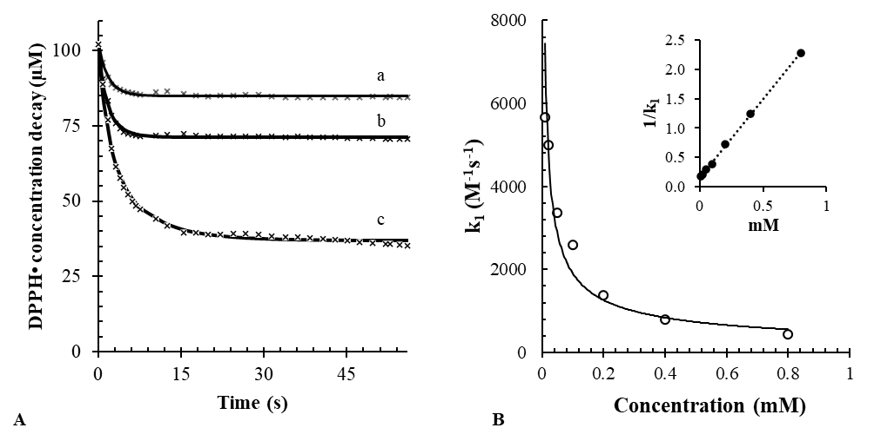

Figure . This is a two-columns figure with an inset.

Where possible, graphs should be drawn with axes clearly labeled, including SI units where appropriate, and with the scale indicated. Diagrams should be neatly drawn with relevant labels.

Colors may be used to enhance the clarity of complex structures. However, be careful on the use of yellow, light green or pink tones. Avoid colored backgrounds, where possible. In general, prefer darker colors (i.e., darker red, blue navy, violet, darker green or teal) for text and lines over a white background.

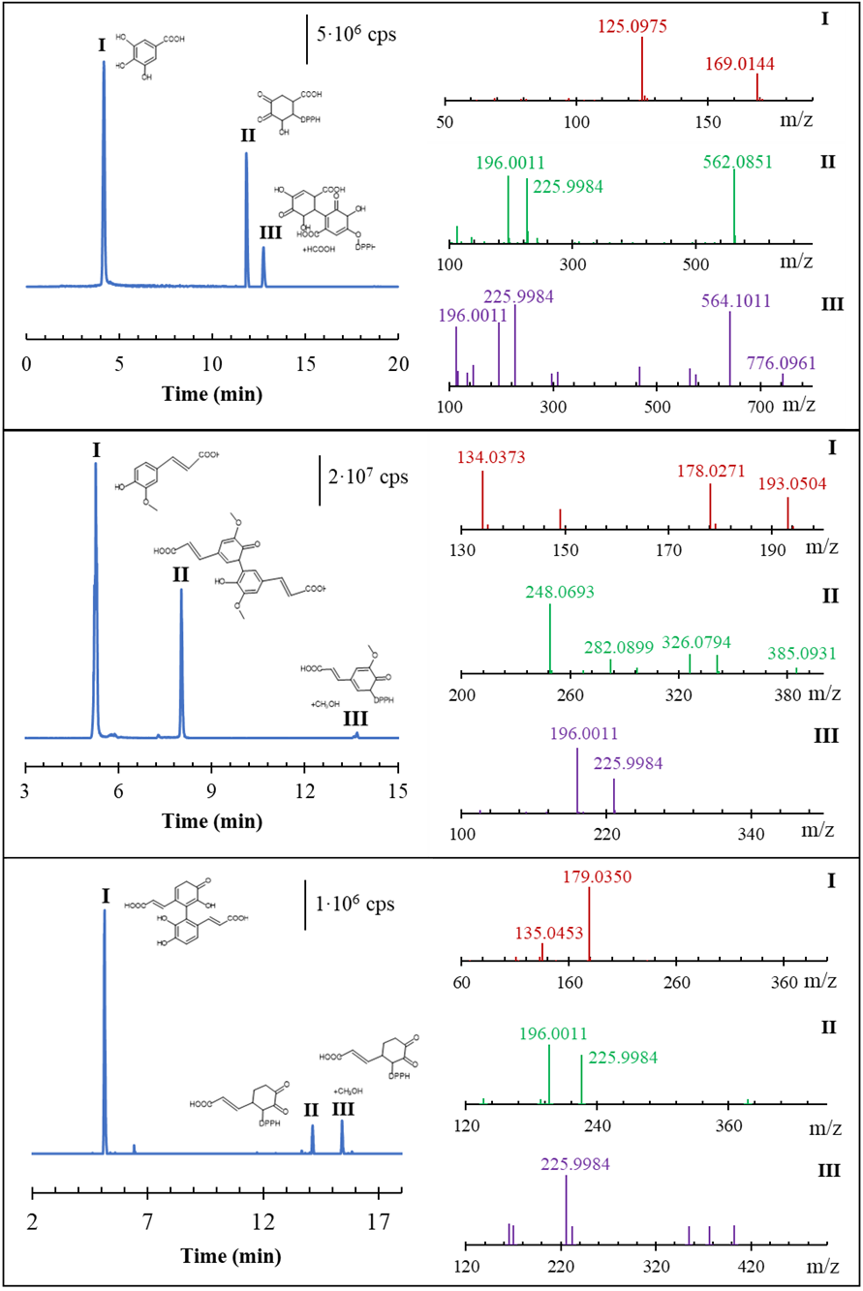

Figure . This is a complex two-columns figure.

## Tables

Tables should be carefully designed to maximize presentation and comprehension of the experimental data with superfluous information excluded. Tables must be self-contained, that is, understandable without reading the text of the article. This includes using footnotes to explain sample names, units, and other relevant information. Useful information not directly relevant to the discussion may be included under Supporting Information.

Tables may be created using a word processor’s table format feature. Ensure each data entry is in its own table cell. Lower case should be used, where possible.

Tables should be numbered consecutively with Arabic numerals (i.e., Table 1, Table 2, etc.). Footnotes in tables should be given letter designations and be cited in the table by italic superscript letters. Each table should be provided with a descriptive heading, which, together with the individual column headings, should make the table self-explanatory. In setting up tabulations, authors are requested to keep in mind the type area of the thesis page (A4), and the column width (8.5 cm), and to make tables conform to the limitations of these dimensions. Arrangements that leave many columns partially filled or that contain much blank space should be avoided. Conversely, arrangements that include >20 columns should be broken into two tables if possible. If significance of values is to be indicated, use a lowercase letter, on-line, one-space after the value.

Legends or captions of tables are placed above. The style is “Caption_Table”. All Table must be cited at least once through the text of the manuscript. For instance:

Table . This is the caption of a Table 90 mm width.

|  |  |  |  |
| --- | --- | --- | --- |
| Area | N | Size (mm)[1] | |
| North | 10 | 125.5 ± 0.4 | |
| South | 10 | 200.5 ± 0.6 | |
| East | 10 | 80.3 ± 0.3 | |
| West | 10 | 140.1 ± 0.5 | |
| *Results as mean ± standard deviation.* | | |

It is recommended to cite every Table with an automatic reference. This saves you time later, when you have to build-up a “List of Tables” and update the cross-references. Cite your Table like in the following example:

“The most important results reported in Table 1 are…”

About lines: Avoid “boxing up” cells. Usually, you need only three horizontal lines, the first two lines delimit the heading, the third delimits the end of the Table. Avoid, where possible, the use of vertical lines. Keep it simple and clear. Align left where possible or if in doubt.

It follows an example of a more complex table:

# Outline (single paragraph in the introduction section)

It is recommended that the introductory chapter include an *Outline* subsection where a *brief* outline of the thesis is provided. For instance:

“In Chapter 2, the approach taken is presented in all of its gory detail. Chapter 3 continues in this vein and presents some rather disturbing graphics. The carnage continues in Chapter 4, where the implications of the main results are explored, ad naseum. The main conclusions of this sordid affair and some future recommendations for avoiding the mistakes gracefully implemented here are given in Chapter 5.”

Note, such outline is only a guideline and other formats are possible.

# Aims (single page)

It is recommended to include an Aimssection (single page) where the main objectives and research questions/hypotheses are explicitly indicated.

# Methods

Describe how you approached the problem and any analytical, computational or experimental methods applied. **Specific experimental methods should be sufficiently detailed for others to repeat the experiments unequivocally.** Generally, it is suggested to omit details of procedures that are common knowledge to those in the field. Brief highlights of published procedures may be included. Describe pertinent and critical factors involved in reactions so the method can be reproduced. Thus, apparatus, reagents, and biological materials used in the study should be detailed. List devices of a specialized nature or instruments that may vary in performance, such that the model used may affect the quality of the data obtained (e.g., spectroscopic resolution). Specify the source, vendor [city and state (or city and country)], and availability of special equipment, reagents, kits, etc. Do not include catalog numbers.

Be careful to emphasize any significant hazards or risks associated with the reported work.

Biological materials should be identified by scientific name (genus, species, authority, and family) and cultivar, if appropriate, together with the site from which the samples were obtained. Specimens obtained from a natural habitat should be preserved by deposit of samples in an herbarium for plants or in a culture collection for microorganisms, with a corresponding collection or strain number listed.

Chemical standards or reagents should include the source, the vendor, the purity and, where pertinent, the CAS number.

# Results and discussion

Results and discussion may be presented in separate sections or combined into a single section. Be complete but concise in discussing findings, comparing results with previous works, and proposing explanations for the results observed. Avoid redundancy (i.e. repeating the same paragraph wording for a series of experiments, or discuss the same results reported either in tables or in figures).

All data must be accompanied by appropriate statistical analyses, including complete information on sampling, replication, and how the statistical method employed was chosen. A great source of example is the NIST/SEMATECH e-Handbook of Statistical Methods: <http://www.itl.nist.gov/div898/handbook/> (link checked on June 2021). A general reference book for statistical analysis in chemistry is (Miller & Miller, 2018):

Miller, J. N., and J. C. Miller. 2018. *Statistics and chemometrics for analytical chemistry*. Harlow, England: Pearson/Prentice Hall.

If possible, pay attention to specify the nature of replicates and make a clear distinction between “independent replicates” and “repeated measurements of the same samples”. Ask to your supervisor in case of doubts. Avoid comparisons or contrasts that are not pertinent. Avoid speculation unsupported by the data obtained. Pay special attention to the design and quality of tables and graphs.

# References

**In-text citations:** Citations will appear typically at the end of the paragraph where in a bibliography at the end of the thesis. Citation style should follow the APA styles or ACS styles (ACS Publications Home Page. https://pubs.acs.org/ (accessed 2021-07-24)). As an example, see the guidelines of the Journal of Agricultural and Food Chemistry. What is mandatory is that the style chosen for the citations must be used coherently through the theses. Consider using a software to manage references and citations, such as RefWorks, EndNote or Mendeley.

Examples of citations of journal articles within the text:

1. Single Author: (R. J. Norby 1999)

2. Two Authors: (C. J. Frost & H. Liang 2000)

3. Three or more Authors: (A. H. Fitter et al. 1999)

Where different references would appear identical when cited in this manner, use letters after the date in the citations and reference list (Secco et al. 2012a, b). Where two authors have the same last name, add their initials (F.J. Zhao et al. 2010). **Order lists of references in date order** (oldest first), and **alphabetically** when of the same date: (Rokas et al. 2003; Kocot et al. 2011; Smith et al. 2011; Struck et al. 2011).

**Bibliography:** A complete bibliography section must be placed at the end of the thesis. Separate bibliographies at the end of each chapter are also possible.

List your references alphabetically. Typical references should follow the styles given below.

Regular research articles:

Brown, J.; Jones, M.; Green, D. Article title. J. Agric. Food Chem. **1980**, 28, 1–4.

Books:

Smith, L; Caldwell, A. Chapter title. In Book Title, edition no.; Keys, F., Park, G., Eds.; Publisher: City, State (or Country if non-U.S.), Year; Vol. no., pp.

For Web pages:

Black, A.; White, B. Page title. URL (http://...) (most recent access date).

# Equations

Numbered equations should be cross-referenced within the text.

For instance:

The rate of the reaction is expressed in eq. 1:

|  |  |  |
| --- | --- | --- |
|  |  | () |

Consider explaining all the variables used in an equation:

|  |  |  |
| --- | --- | --- |
|  | $$A=ε∙l∙C$$ | (2) |
|  | where: $ε$ is the molar extinction coefficient in $M^{-1}cm^{-1}$; $l$ is the length of the cuvet in $cm$; $C$ is the concentration of the reagent in $M$. |  |

When cross-referencing equations, enclose the equation number in parentheses. For instance: eq. (1) and eq. are examples of equations.

# Conclusions

State the main findings and conclusions of your work here, reflect critically upon your approach. Make recommendations for future research and state any implications that your findings may have for the state-of-the-art or practice.

# Use of Mendeley for Bibliography

In Scopus

Save your references from Scopus (www.scopus.com) in a .bib file 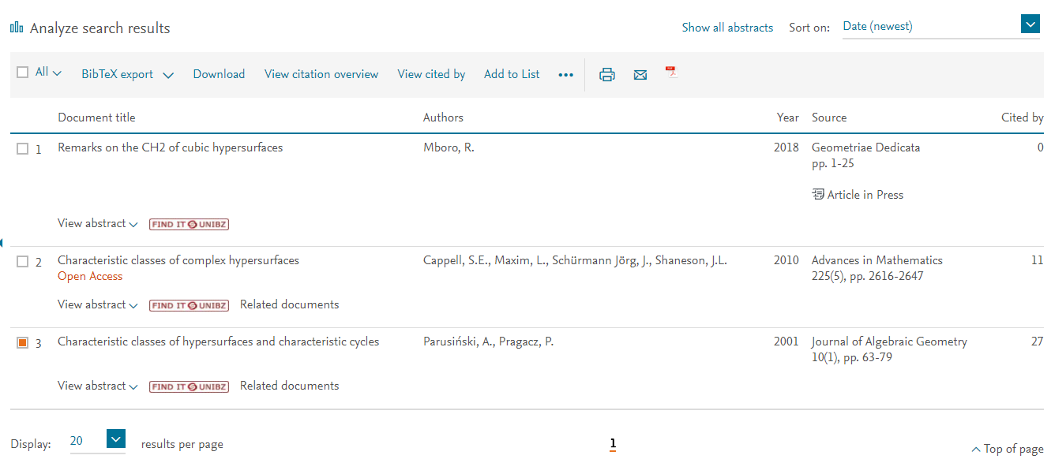

Download the software Mendeley (<https://www.mendeley.com>) and install it

Register a free account and login

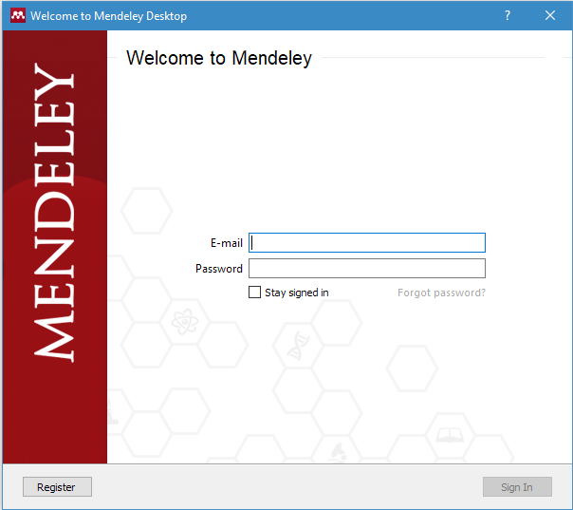 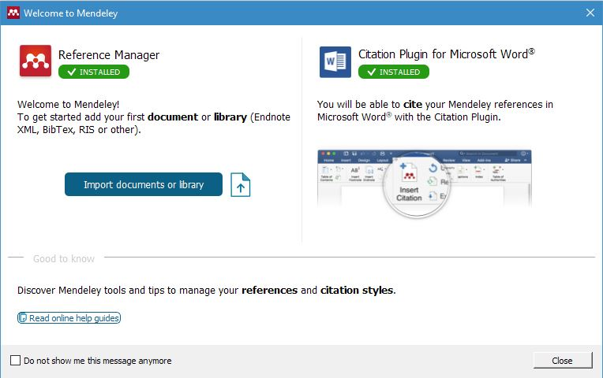

A new menu will appear in the “Reference” tab of your Microsoft Word.

In Mendeley (1.19)

To import new documents: (File->Add file ) and open your .bib document

It is recommended that the Mendeley Web Extension be used. This extension allows one to grab citations from web pages automatically (e.g. from ieeexplore.org or others), instead of having to insert the bibliographic data manually.

In Word (2016)

*To cite a document in the text*: (References->Insert Citation ) use “IEEE” style

*Example:* Parusiński et al [3] have studied….

*To create the bibliography*: (References-> bibliography )

# Bibliography

Miller, J. N., & Miller, J. C. (2018). *Statistics and chemometrics for analytical chemistry.* Harlow, England: Pearson/Prentice Hall.

National Institute of Standard and Technology (NIST). (2019). *(GLP 9) Good Laboratory Practice for Rounding Expanded Uncertainties and Calibration Values.*

1. (optional)

Index (optional)

B

bibliography, 2

by chapter, 5

C

chapter

numbered, 1

unnumbered, 1

F

figures, 3

L

LATEX, 1

T

tables, 3

1. This is a footnote where you can specify something. Go to the command: References/Insert Footnote.