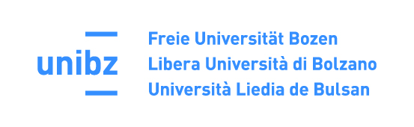

**Sprachenzentrum**

**Centro linguistico**

**Language Centre**

**Scores and Evaluation Criteria for the Language Exam of the free univesity of bozen-bolzano**

**ModulE I (listening, reading)**

To pass Module I, which is a prerequisite for the other 2 modules, at least 60% of the available points must be achieved (24 out of 40 points).

**Module II (WRITTEN PRODUCTION)**

The written tests are evaluated according to the following four criteria, each with a score from 0 to 5:

**Content and task completion:** Assesses the completeness, relevance, and depth with which the required points are addressed.

**Lexis:** Considers the breadth and appropriateness of vocabulary, use of synonyms, collocations, and the ability to compensate for any gaps.

**Grammar, spelling and punctuation:** Measures the variety and correctness of grammatical structures, as well as spelling accuracy and punctuation use.

**Coherence and cohesion:** Evaluates the logical organization of the text, effective use of connectors and cohesive devices, and clarity in the hierarchy of information

To pass Module II, at least 60% of the available points must be achieved (12 out of 20).

**Module III (oral production)**

The oral tests are evaluated according to the following four criteria, each with a score from 0 to 5:

**Communicative effectiveness:** Concerns the ability to complete assigned tasks, organize speech, and ensure content relevance.

**Lexis:** Evaluates the breadth of vocabulary, the ability to express oneself clearly, and to compensate for any gaps.

**Grammar:** Considers the variety and correctness of the grammatical structures used.

**Fluency, pronunciation, and intonation:** Measures speech fluency, pronunciation clarity, and use of intonation.

To pass Module III, at least 60% of the available points must be achieved (12 out of 20).